Birdwood High School
Stage 2 English
Task: Responding to Texts: Film Analysis Essay (10%)
Teacher: Mr Djukic – mak.djukic680@schools.sa.edu.au

DRAFT Deadline (Email and Hard Copy): T1, Wk 8 Tuesday 4pm
FINAL COPY: (1 week from return of marked draft) ~~Wk 10
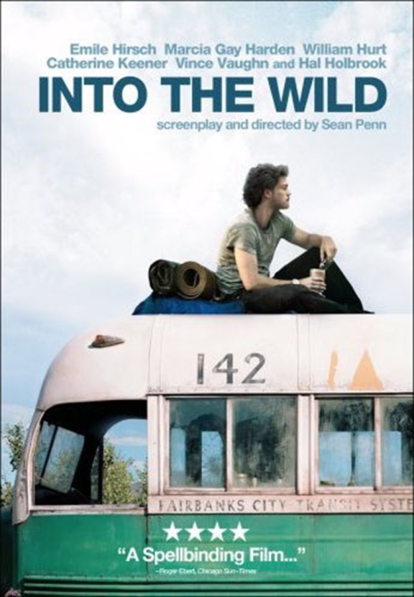
Assignment
Students will write a 1000 word essay: they will discuss how effective a creator of a film is in persuading the viewer and influencing opinions around an idea (theme), through the use of filmic techniques.

In their writing students will analyse two or three uses of film techniques in the text, particular examples within the text, and comment on their effectiveness in developing the main idea/theme/presenting these ideas.

Some options include the below, or negotiable:

- How does Director Sean Penn of 2007 film ‘Into The Wild’ explore the idea of…
freedom and independence / isolation and loneliness / humans and nature / family / survival / truth
…and how does this impact on the audience?

- How effectively does the Director of ‘Into The Wild’ communicate the idea of ‘x’?

- Was Christopher selfish or noble? **
- Was he escaping society or his family? **
- Does he die as Christopher McCandless or Alexander Supertramp? **
**Discuss, basing your answer around the Director’s intent, the techniques used and how these impact/affect the audience.

Assignment Conditions
1000 Word Essay or negotiable multimodal presentation – Oral task.
Process
- View the film ‘Into The Wild’ (2007, Dir. Sean Penn) in its entirety.
- Discuss the film, your opinions around it, and what you think the ‘big ideas’ of the text are.
- View and take notes on the PowerPoint presentation,
making note of the themes present, and the filmic techniques used to communicate these ideas.
- Choose a theme, perhaps altering it…
(e.g. ‘Freedom > ‘Freedom is not being free’)
- Pick which 2 or 3 techniques did the creator employ to communicate this idea?
e.g. Mise en Scene (costume, lighting, setting); Cinematography (shots, angles, composition); Soundtrack (custom folk acoustic soundtrack by Eddie Vedder, lack of noise);
- View the film again; looking for particular evidence that proves your point.
(e.g. My theme is ‘Freedom’ and the technique is cinematography – I’ll find two scenes to contrast, as I noticed there’s wide landscape shots in nature and closer-in shots in society – I think this has an effect on the viewer…)
- Fill in the A3 scaffolding sheet – this is the skeleton of your assignment; whether essay or oral task.
It identifies techniques, evidence, and explanations of your argument.
- Craft a Question: it must mention your chosen theme, techniques and whether this was effective.
e.g. “How has the Director of ‘Into The Wild’ employed filmic techniques to develop the theme of XYZ and influence the audience?”
e.g. “How effective… To What Extent…”
- Write the 2-3 Main Body paragraphs. TEEL paragraph structure is recommended
(Topic Sentence, Explain The Paragraph’s Idea; Evidence analysed; Link to the next paragraph)

- Write your Introduction.
Consider providing a sentence or two of context/summary; preview the director’s intent; preview the techniques used; preview of to what degree they were successful in communicating the theme.

- Write Conclusion.
This tends to be your Topic Sentences re-wroded to flow, as well sa a final summary of your evaluation of how effective these techniques were. End on a strong/poetic note.
Performance Standards: ‘A’ Grade Criteria
- KU1: Comprehensive knowledge and understanding of the ideas and perspectives in a range of texts.
  - Comprehend the themes
- KU2: Thorough knowledge and understanding of the ways in which authors of texts use a range of language features, stylistic features, and conventions to make meaning.
  - Understand the use and effects of Stylistic features = genre and techniques
  - Stylistic elements of film include;
- The Narrative, or Plot
- Soundtack
- Editing
- Cinematography; angles, shots, composition.
- Mise en Scene: lighting, costume, setting
- Genre
- Allusion to other texts / Intertextuality
- Irony
  - Explain how the Director makes meaning = communicate a point or message about the theme/consider: what is the point of the text? Why is it important?
- An1: Perceptive analysis of language features, stylistic features, and conventions used in texts, and thoughtful evaluation of how they influence audiences.
  - The effect of language, style and convention on the audience
- An2: Sophisticated analysis and evaluation of ways in which ideas, perspectives, and aspects of culture are represented in texts.
- Analyse which techniques are used to portray/explore theme; their effectiveness in persuading an audience around the central idea.
  - Effectiveness:
  - Did it fulfil its purpose?
  - Did it convince the audience?
  - Did it meet the requirments of the genre?
  - Etc
- Ap2: Fluently incorporated use of evidence from texts to develop and support a response.
  - Integrated, appropriately punctuated quotations, captioned screenshots to illustrate a point.
Helpful Sites:
WikiQuotes  Provides quotes from the film. | https://en.wikiquote.org/wiki/Into_the_Wild_(film)
IMDB: Into The Wild
Eddie Vedder’s Song Lyrics
Performance Standards for Stage 2 English: Film Analysis Essay
KU1, KU2
An1, An2
Ap2
- | Knowledge and Understanding | Analysis | Application
A | Comprehensive knowledge and understanding of ideas and perspectives in a range of texts.  Thorough knowledge and understanding of ways in which creators of texts use a range of language features, stylistic features, and conventions to make meaning. | Complex analysis of ideas, perspectives, and/or aspects of culture represented in texts.  Perceptive analysis of language features, stylistic features, and conventions used in texts, and thoughtful evaluation of how these influence audiences. | Fluently integrated use of evidence from texts to develop and support a response.
B | Knowledge and understanding of ideas and perspectives in a range of texts.  Knowledge and understanding of ways in which creators of texts use a range of language features, stylistic features, and conventions to make meaning. | Detailed analysis of ideas, perspectives, and/or aspects of culture represented in texts.  Detailed analysis of language features, stylistic features, and conventions, and evaluation of how these influence audiences. | Appropriate use of evidence from texts to develop and support a response.
C | Knowledge and understanding of some ideas and perspectives in texts.  Knowledge and understanding of ways in which creators of texts use some language features, stylistic features, and conventions to make meaning. | Analysis of some ideas and perspectives represented in texts.  Description and some analysis of different language features, stylistic features, and conventions, and/or some evaluation of how these influence audiences. | Selection of some evidence from texts to develop and support a response.
D | Knowledge and understanding of some ideas in a narrow range texts.  Some knowledge and understanding of ways in which creators of texts use language features and conventions to make meaning. | Description of some ideas in texts.  Description of some language features, stylistic features, and/or conventions. | Partial use of basic evidence from texts to develop a response.
E | Identification of an idea in a text.  Identification of a limited range of ways in which creators of texts use language techniques. | Reference to an idea in a text.  Recognition of language or stylistic features. | Limited use of evidence from a text in a response.

