Some Helpful Terms for the Intertextual Study
(You will need to speak with me and search for terms)
There are conventions that define each text type in terms of the way they are organised and structured.
Novel / Narrative
Narrative Conventions are techniques used to tell a story to the reader. Narrative Conventions include:
- points of view,
  - 1st person (I)
  - 3rd person (he, she)
- Characterisation – how characters act and behave, whether they are sympathetic or not.
- descriptive language – may help set a tone or mood
- conflict – what is the conflict? Between characters?
- Climax – the highest point of tension
- Plot – the story/events of the text
- Time – How much passes?
- form etc... – The form the text takes impacts meaning, eg graphic novel or novel.

Film and TV Conventions - http://www.elementsofcinema.com/
- Genre tends to have its own set of conventions…
  - Horror might feature a creepy, dark and isolated setting, disturbing low-pitched sounds, dark colours, death and dark plots, vulnerable and brave and stereotypical characters, fast paced editing.
See: The Cabin In The Woods (plays with conventions very nicely!), Get Out, IT, Alien
  - Action – high energy action, simplistic plot usually based around revenge or other ‘macho’ ideas, masculine heroes, damsels in distress, good vs bad, intended for audience escapism, or sometimes reinforcing current political ideas, especially if the villain is a minority/foreigner (e.g. a Russian)., stereotypical characters and archetypes.
See: Fast and Furious franchise films, James Bond, Terminator
  - Drama focuses on human interaction, emotion, human or societal growth and may be a tragedy, comedy, or plain drama.
See: The Fault In Our Stars, Schindler’s List, Perks of Being A Wallflower, etc.
  - Science-Fiction and Fantasy usually expresses the potential of mankind, or reflects a current worry in society. This might mean futuristic landscape settings, dystopian governments or worlds, an outsider protagonist.
See: Planet of The Apes, Avatar, District 9, The Hunger Games, Lord of the RIngs
  - Musicals emphasize human emotion, with both the music/lyrics and choreography revealing the character’s inner world or turmoil. Colours, symbols, acting also play a part.
See: Hairspray, Grease, Chicago
  - Comedy usually feature fairly straightforward plots that may feature gags, slapstick, situational comedy or character based comedy. Generally characters are thrown haplessly into a new situation and must work their way through it. Stereotypes are used and the soundtrack may play a part.
See: Shaun of the Dead, The Hangover, Bridesmaids

- Setting
  - Realism (time and place of the setting, the historical context, made known? E.g. 1960s Alabama – we’re in the Deep South during segregation and civil rights movements)
  - Atmosphere (reinforces a desired mood or tone – e.g. in Gran Torino, the setting of Detroit, a dilapidated city past its prime sets a similar mood and reinforces the theme of ‘old vs new’.
  - Symbolism (can be conveyed through setting – does the setting represent something else? E.g. in ‘Forever War’ (1974) the bizarre 23rd century Earth Mandella returns to reflects 1970s America, as the setting was based on the author’s Vietnam War experiences. A storm could represent inner turmoil or a twist in the plot.
  - Location
In Witness (1985), on the day after rejecting Rachel’s (Kelly McGillis) seduction, John Book (Harrison Ford) explains to her why nothing could have happened between them the night before. Quite conveniently, the confrontation takes place in a barn, while Rachel is collecting eggs. The location emphasizes Rachel’s responsibilities as a woman. If they had made love and Rachel gotten pregnant, she would have to carry the baby and eventually give birth. Also, during the conversation, John stands outside the barn, thus being physically separated from Rachel by the barn’s door. In this case, the door functions as a metaphor of the social and cultural barriers that keeps them a part.
The final confrontation in The Graduate takes place in a church. Ben tries to prevent Elaine (Katherine Ross) from getting married, but he arrives too late. Nonetheless, when Elaine sees him, she sprints to him, and they run away. When the couple is cornered by infuriated parents and relatives, Ben starts swinging a cross to avoid them. As they exit, Ben uses the cross to hold the church’s doors shut. The prop (cross) and location (church) offer a comment on religious institutions, perhaps implying that Elaine’s parents are trapped by traditional believes and practices.

- Characterisation
  - Stereotypes (can reinforce existing ways of thinking about certain groups.
They A) appeal to prejudices of certain audiences (e.g. Mean Girls)
Or B) stereotypes may be deliberately broken (Cabin In The Woods completely subverts the idea of the ‘virginal’ one, the ‘nerd’, the ‘jock’, etc, to play with our expectations in a self-reflexive way).
  - Sympathetic or unsympathetic characters (compare Forrest Gump and Jordan Baker of Wolf of Wall Street – one is loveable straight away and endearing and we sympathise – the other is a vile human who we like purely because he is the protagonist.)
- Plot
  - Linear plot – events occur in chronological order, as if a day is unfoilding in front of them and us – their progression of learning and shocks come to them and us at the same time.
  - Manipulation of time – flashbacks (The Reader)
  - Twist ending – the ending makes sense but is a twist on what we’d been lead to believe. (The Sixth Sense, The Village)
  - Open ending – the ending is left open to have the audience keep thinking about the issue long after the film is over.

- Mise en Scene: http://www.elementsofcinema.com/directing/mise-en-scene-in-films/
The arrangement of everything that appears in the framing – actors, lighting, décor, props, costume – is called mise-en-scène, a French term that means “placing on stage.
  - Acting – naturalistic or unnatural, blocky acting? Method acting?
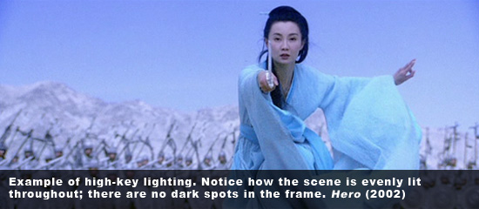
  - Lighting
High-key lighting is often seen in romantic comedies and musicals, encompassing an even lighting pattern and avoiding dark areas in the frame. Everything looks bright with little to no shadow at all. High-key lighting has little dramatic effect itself.

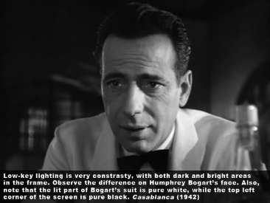
Low-key lighting is often seen in horror movies and thrillers, comprising of a lighting pattern that has both bright and dark areas in the frame. The chiaroscuro (Italian: bright-dark) technique, long used by painters, is characterized by strong contrast, often employed to unnerve the audience.
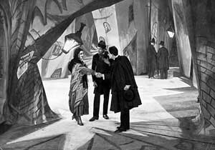
In some instances, the mise-en- scène is designed to evoke emotions that permeate the whole movie. For example in the German expressionist film The Cabinet of Dr. Caligari (1920), distorted shapes and claustrophobic scenery are implemented to disturb the audience and enhance the horror.
  - Set Design – how do the props and other set elements communicate an idea? (e.g. consider Norman Bates’ bedroom full of taxidermied animals in Psycho – weeeeirdo! In Rear Window, a photo helps explain some of the exposition/backstory prior to the film.)
  - Costume
The obvious purpose of costuming is to dress an actor according to his character. Lawyers wear suits, nurses wear scrubs, and a drifter could wear worn out shoes, ragged shirt, and baggy pants.
But, more than that, costuming can also be used to establish someone’s hierarchic level. Regimentals, for instance, bear the status of the person who wears it. And even the color may distinguish an enemy from a friend. In The Good, the Bad and the Ugly (1966), a comic situation arises when Blondie (Clint Eastwood) heads toward the enemy cavalry that was covered in dust. When the enemy general dusts off his sleeve, his apparently gray uniform turns blue, making it obvious that our beloved protagonist was going into the shark’s mouth. Consider The Graduate, where Mrs Robinson wears a fur coat that makes her look like a predator hunting for prey – a cougar, perhaps?
  - Soundtrack: Music
Like most elements of filmmaking, the goal of music is to augment emotions and manipulate viewers.
It can suit a mood or scene: See Jaws theme… Du Nuh, Du Nuh, DuNuhDuN
It can be contrapuntal, in effect, juxtaposed against the imagery. Imagine an explosion with soft classical music in the background.
  - Soundtrack: Diegetic Sound (literal sound): Sound is called diegetic when its source is visible or implied in the world of the film. Common diegetic sounds present in most films are:
- actors speaking to each other (dialogue)
- sounds originating from any object on the screen, like footsteps and police sirens
- music that comes from a sound system or orchestra
  - Soundtrack: Non-diegetic
Sound is said to be nondiegetic when its source is not present or implied in the narrative universe. Common instances are:
music or score, used to augment emotions
actor’s commentary or narration
any extra sound added for effect

Tone
Consider the difference between ‘The Evil Dead’ and ‘Shaun of the Dead’: the genre enforces a different tone. Texts can be humorous, satirical, angry, patronising, sad, etc.

Editing
- Non-linear editing, eg Eternal Sunshine of the Spotless Mind, Into The Wild
- Linear
- Cross-cuts
- Jump-cuts

