Writing about Film Style: ‘Into The Wild’
The following paragraphs show how several elements of film style are combined in the key scenes of a film to: construct character, convey context and develop the narrative.
This person has written a paragraph around two scenes; how they CONTRAST; and how this contrast reflects the contrasting themes in the film. By contrasting techniques/scenes, Penn demonstrates the contrast in themes.
Freedom / Trapped
Solitude / Family
etc
The editing in the first minutes of Into The Wild juxtaposes two scenes: Chris’ mother’s distress on ‘hearing’ (or dreaming of) his voice, and Chris’ views of wilderness from a train as he arrives in Alaska. Contrasts establish important ideas in the text; in his parents’ world, lighting is dim and blue. Camera angles and shot composition are tight and claustrophobic; the soundtrack comprises natural sound effects and dialogue. In the next scenes, bright white light reflects the broad, snowy wilderness; close-up images are interspersed with wide shots showing the long railway lines and the vast countryside; the soundtrack is primarily music – gentle guitar-playing and humming. Thus the film efficiently conveys the grief and conflict of Chris McCandless’ family life and his parents’ experience after his disappearance, as well as the contrasting themes of his journey: solitude, wilderness, adventure and freedom. 141 words
Essay Features | Phrases or Words in this column
Colour-code:
Topic Sentence
Explanation
Evidence
Linking Sentence
Stylistic Feature (Filmic Technique)

Audience Impact

Themes
Evaluation/Effectiveness of Technique
Analytical or Connecting Phrases/Words | Juxtaposition ;

So, how could we approach this task?

A focus in your paragraph on…
- A scene and all the cinematic features it has
- A technique used across several scenes
- Compare and contrast two scenes in the film, and how they each use one or more techniques.

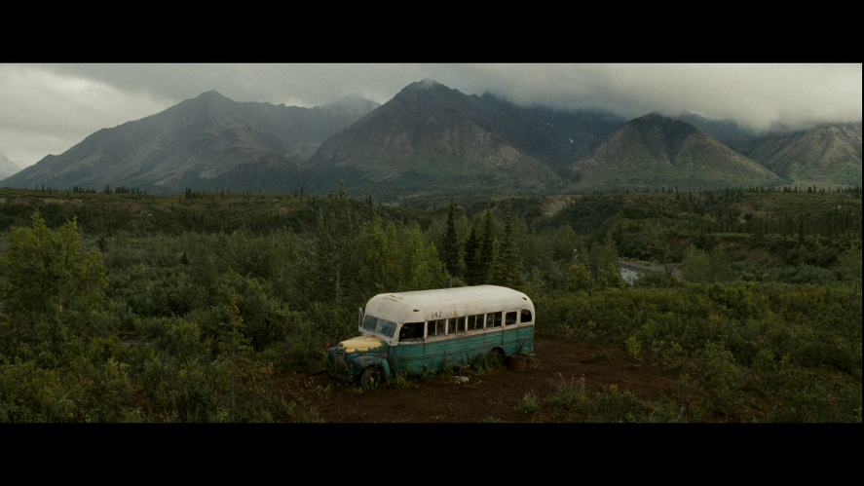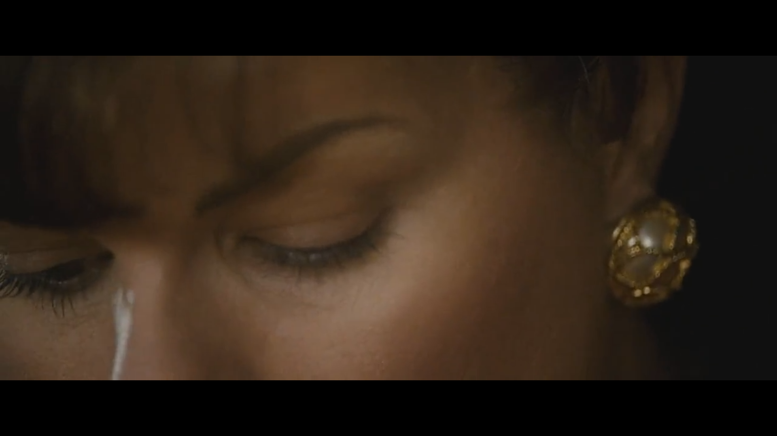
Fig 2. You guys write this one!
Fig. 1. This shot of the Alaskan Magic Bus serves as a wide-angle reminder to the audience of how freeing the great outdoors are to Christopher; especially when compared to the claustrophobic close-ups of society shots (Fig.2). Furthermore, this shot serves to remind the audience of Christopher’s isolation in the wild, one of the key themes.

