Birdwood High School
Stage 2 English
Task: Creating Texts: Oral – TED Talk (10%)
Teacher: Mr Djukic – mak.djukic680@schools.sa.edu.au

- DRAFT Deadline (Email and Hard Copy): T2, Wk 2 Tuesday IN-CLASS
- FINAL COPY:
PRESENTING IN-CLASS Roughly T2, Wk 3 Thurs; Wk 4 Tues
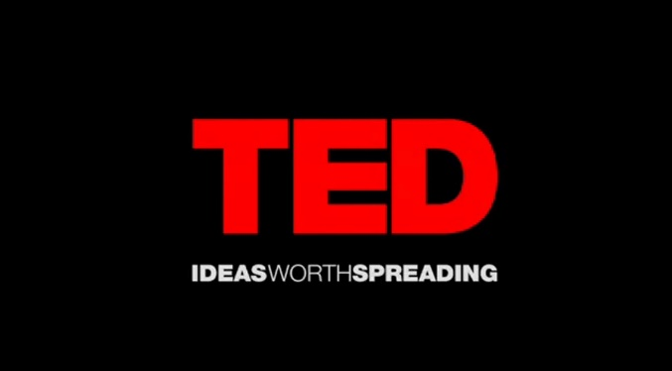
Assignment Conditions

Students persuade viewers to take a particular viewpoint in a 6-minute maximum Oral Presentation in the style of a TED Talk.

Your Prompt:
“This is how we change the world.”

Students will use persuasive techniques, draft an 800-1000 word script (6 minute equivalent), have a visual presentation (Powerpoint or Multi-modal) and present to a group or negotiable.

Process
- View a range of Persuasive presentations like TED Talks, Charity pledges, etc, taking note of how the presenter’s word choices, pacing, persuasive techniques and body language effectively communicate the ideas.
- Study some language and stylistic features used in speeches by completing the MLK ‘I Have A Dream’ speech worksheet.
- Study the ‘Insight’ Persuasive Techniques Sheet.
- Practice a 1-minute/200 word persuasive speech using these techniques.
- Choose your focus: “This is how we change the world.” How? A charity? Society? Environment? Laws and policy? Whose world?
- Write your script:
    - Strong opening: An anecdote?
    - 3+ Paragraphs: A Brainstorm may help with all the areas you should cover…
Who / What / When / Where / Why / Which / How?
    - Use a range of persuasive techniques
    - Strong finish – appeal to your audience’s sense of…?

- Create a HIGHLY VISUAL presentation via PowerPoint or other format.
- PRACTICE reading this out to yourself, family, your dog, and TIME YOURSELF. Anything past 6 minutes is discounted.
- DRAFT:
Provide Teacher with:
Transcript (Highlighted with Persuasive Techniques) and DOUBLE-SPACED, Size 11 Calibri, Double-Sided Pages
Powerpoint Presentation (printed with 2-3 slides per page)
Your Cue Cards (script broken down into cards and dotpoints)
- FINAL PRESENTATION:
Provide Teacher with:
Assignment Sheet
Transcript (Highlighted with Persuasive Techniques)
Powerpoint Presentation (printed with 2-3 slides per page)
Your Cue Cards (script broken down into cards and dotpoints)

What Does An ‘A’ Look Like?
Consider:
- Writing with a specific reader in mind by choosing a particular publication to write for (TED)
- Text conventions (use appropriate structure and layout for your chosen text type)
- Language features (metaphors, similes, alliteration, symbols, personification, allusions, hyperbole, onomatopoeia)
- Stylistic features (the way you will apply conventions and techniques to give your piece a certain tone/mood/effect – is this a serious, somber, funny, persuasive, text?
- Innovative interpretations to the task
- Conferencing your decisions with the teacher as you progress

Performance Standards: ‘A’ Grade Criteria
KU2: Thorough knowledge and understanding of ways in which creators of texts use a range of language features, stylistic features, and conventions to make meaning.
- Understand where and how to use the techniques in the most impactful places.
KU3: Extensive knowledge and understanding of a wide range of ways in which texts are created for different purposes, audiences, and contexts.
- Deeply understand your purpose, where you are presenting (context), and your audience’s needs (interests, age, engagement, etc).
AP1: Versatile and precise use of language and stylistic features to create a wide range of coherent texts that address the purpose, audience, and context.
- Create a logical, engaging, coherent text
- Address your purpose strongly
- Meet your audience’s needs, keep them engaged
- Use a range of persuasive techniques for effect
AP3: Sophisticated use of accurate, clear, and fluent expression.
- Speak with minimal reading; cue cards may help; maintain a good level of eye-contact
- Use sophisticated language that suits your context and audience.
- Proof-read and listen to yourself practice. Present it to others for feedback.

Performance Standards for Stage 2 English
Creating Texts: Oral – TED Talk
- | Knowledge and Understanding | Analysis | Application
A | Comprehensive knowledge and understanding of ideas and perspectives in a range of texts.  Thorough knowledge and understanding of ways in which creators of texts use a range of language features, stylistic features, and conventions to make meaning.  Extensive knowledge and understanding of a wide range of ways in which texts are created for different purposes, audiences, and contexts. | Complex analysis of ideas, perspectives, and/or aspects of culture represented in texts.  Perceptive analysis of language features, stylistic features, and conventions used in texts, and thoughtful evaluation of how these influence audiences.  Critical analysis of similarities and differences when comparing texts. | Versatile and precise use of language and stylistic features to create a wide range of coherent texts that address the purpose, audience, and context.  Fluently integrated use of evidence from texts to develop and support a response.  Sophisticated use of accurate, clear, and fluent expression.
B | Knowledge and understanding of ideas and perspectives in a range of texts.  Knowledge and understanding of ways in which creators of texts use a range of language features, stylistic features, and conventions to make meaning.  Knowledge and understanding of a range of ways in which texts are created for different purposes, contexts, and audiences. | Detailed analysis of ideas, perspectives, and/or aspects of culture represented in texts.  Detailed analysis of language features, stylistic features, and conventions, and evaluation of how these influence audiences.  Clear analysis of similarities and differences when comparing texts. | Accurate use of language and stylistic features to create a range of coherent texts that address the purpose, context, and audience.  Appropriate use of evidence from texts to develop and support a response.  Consistent use of accurate, clear, and fluent expression.
C | Knowledge and understanding of some ideas and perspectives in texts.  Knowledge and understanding of ways in which creators of texts use some language features, stylistic features, and conventions to make meaning.  Knowledge and understanding of ways in which everyday texts are created for different purposes, contexts, and audiences. | Analysis of some ideas and perspectives represented in texts.  Description and some analysis of different language features, stylistic features, and conventions, and/or some evaluation of how these influence audiences.  Analysis of some similarities and differences when comparing texts. | Generally accurate use of language and stylistic features to create texts that address the purpose, context, and audience.  Selection of some evidence from texts to develop and support a response.  Appropriate use of accurate, clear, and fluent expression.
D | Knowledge and understanding of some ideas in a narrow range texts.  Some knowledge and understanding of ways in which creators of texts use language features and conventions to make meaning.  Knowledge and understanding of ways in which some everyday texts are created for different purposes and audiences. | Description of some ideas in texts.  Description of some language features, stylistic features, and/or conventions.  Description of some similarities and differences in texts. | Use of some language and stylistic features to create a narrow range of texts.  Partial use of basic evidence from texts to develop a response.  Inconsistent use of expression.
E | Identification of an idea in a text.  Identification of a limited range of ways in which creators of texts use language techniques.  Recognition of one or more ways in which a familiar text is created. | Reference to an idea in a text.  Recognition of language or stylistic features.  Recognition of a simple connection between texts. | Restricted use of language or stylistic features to create a text.  Limited use of evidence from a text in a response.  Limited use of clear expression.

